# We first used a survey among students about the flux of students. Then we made some scripts using python to make .net files for pyjek and tulip in order to make, analyze and implement different Graphs

# Analysis :

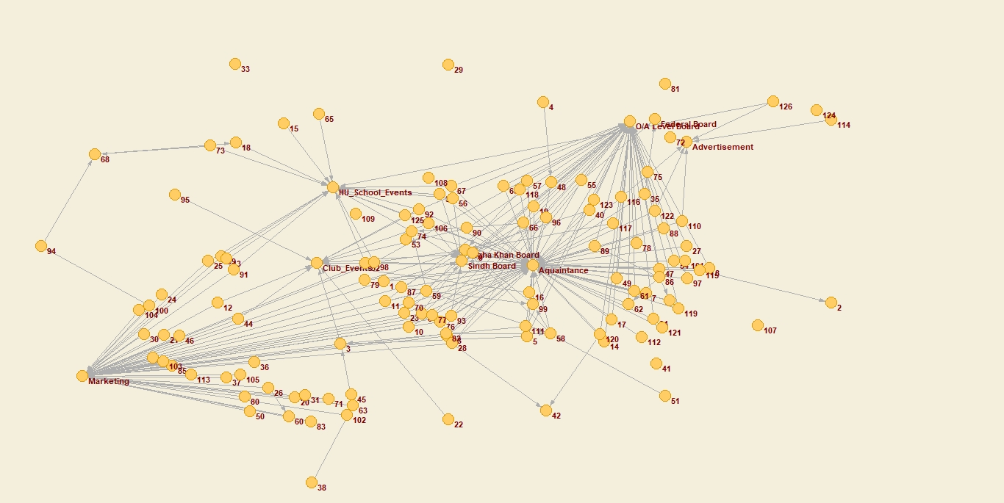

Fig 1 Graph Network of overall networks of Students with Students & Super Nodes

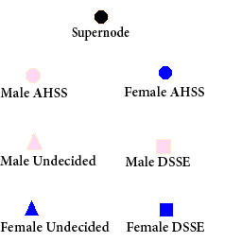

Fig 2 The Scale to be followed in all the graphs

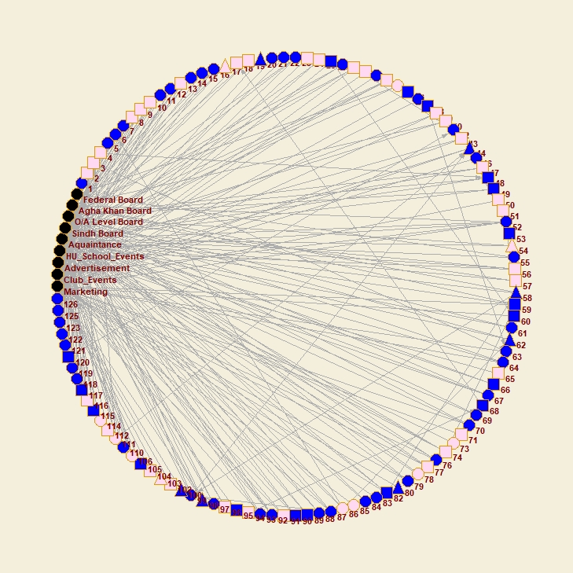

Fig 3 Refined Graph Network of overall networks of Students with Students & Super Nodes

**Degree**

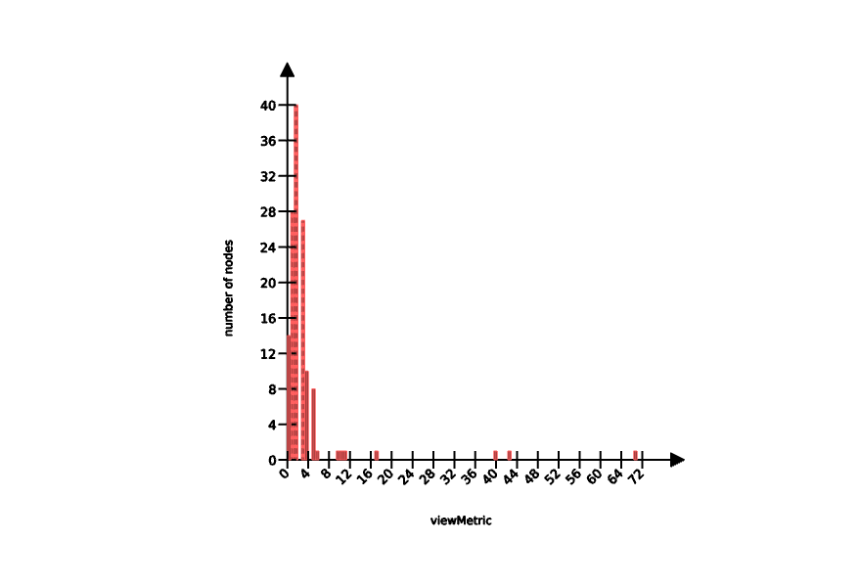

**Betweeness centrality**

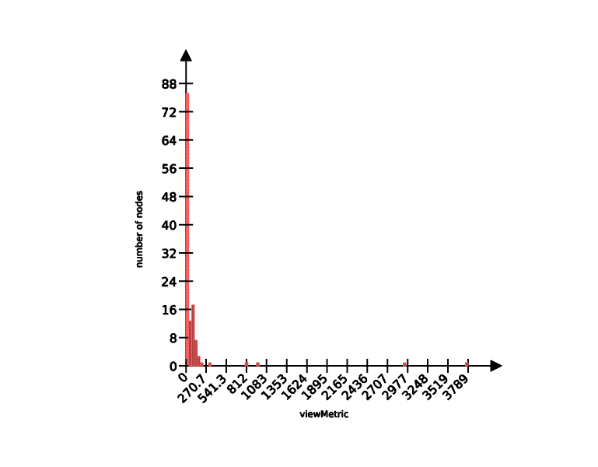

## 4.1 - Degree Analysis

We first applied degree analysis to the refined graph (shown in Fig 2) and obtained the following graph.

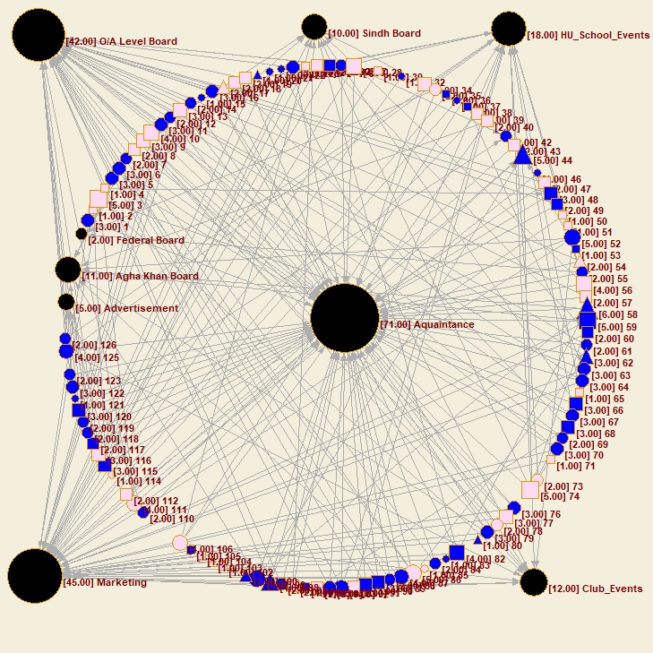

Fig 4 Degree Analysis of Graph Network of overall networks of Students with Students & Super Nodes

After applying the degree analysis, the ‘Acquaintance’ node enjoys the most central position and is the most significant factor in influencing the new students. Considering this graph, it felt like our hypothesis is going to fail because we considered ‘Marketing’ as the most important factor.

In order to satisfy our suspicion, we broke down the graph by only considering the Marketing and Acquaintance factors. The following graph is then obtained, and it reaffirmed the findings of our previous graph i.e. the emergence of ‘Acquaintance’ as the strongest factor with degree 71 rather than ‘Marketing’ whose degree was 45.

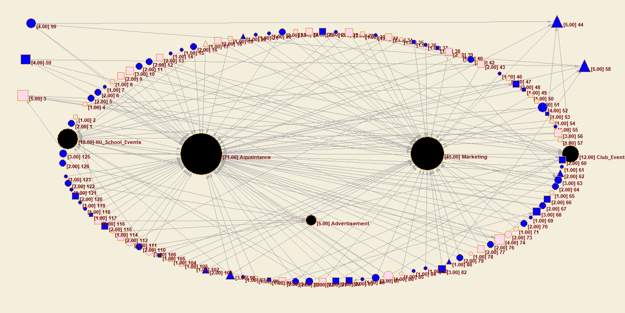

Fig 5 Degree Analysis of Students with ‘Marketing’ & ‘Acquaintance’

Not only this, we also identified the role of Educational Boards of our respondents by reducing our graph to only students and Educational Boards and applying degree analysis on it. It gave us interesting findings about how the students were interconnected through their boards.

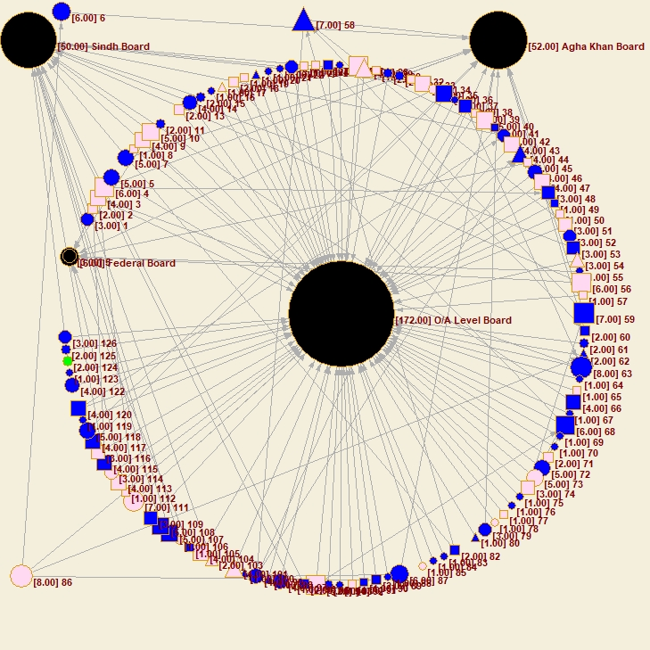

Fig 6 Degree Analysis of Boards and Students

In Fig 5, we identified some critical nodes acting as bridges between different Educational Boards. For example, Node 86 (an AHSS Male), Node 6 (an AHSS Female) and Node 58 (an Undecided Female) were identified as a bridge between ‘Agha Khan Board’ and ‘O/A Level Board’. This graph also reiterated our raw data findings which showed O/A Level Board as the prominent background, with the highest degree of 172, of most of our respondents. The pie chart below shows the raw data findings about Educational Background of our respondents.

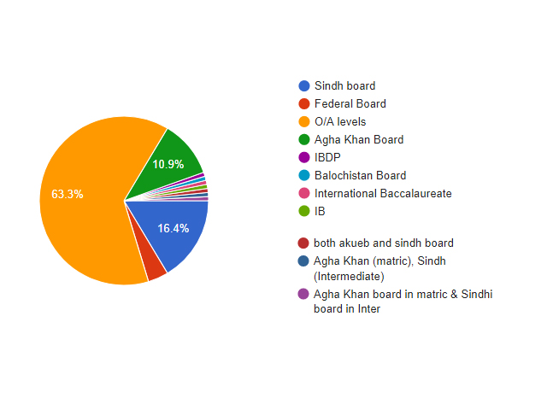

Fig 7 Pie Chart of Distribution of Educational backgrounds (Local School Boards)

## 4.2 – Sex, School and Batch distribution

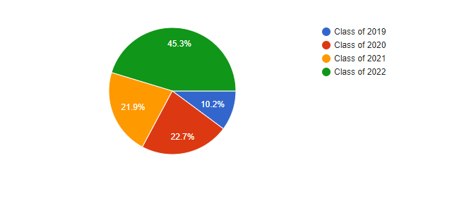

Fig 8 Batch Distribution of Respondents

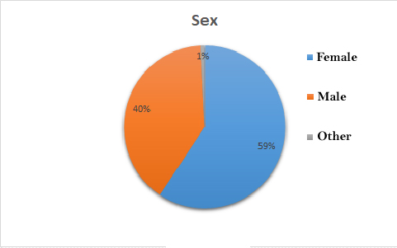

Fig 9 Gender Distribution of Respondents

The following chart gives us the data for the schools (DSSE & AHSS) of Habib University that the respondents belonged to. The response from students of both schools was balanced.

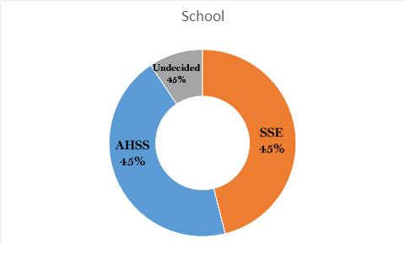

10%

Fig 10 Schools (DSSE & AHSS) Distribution of Respondents

## 4.3 – The Strength of Weak Ties

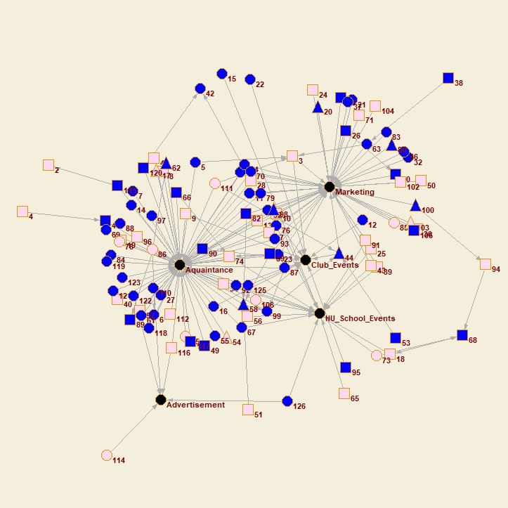

Fig 11 Showing Weak Ties, Bridges & Cut-vertices between Super nodes

## 4.4 - K-Node, Eccentricity and Prestige

Some important parameters to determine the importance of individual nodes as well as network’s importance. For the same reason, the k-cores of this network was calculated. The findings are attached below.

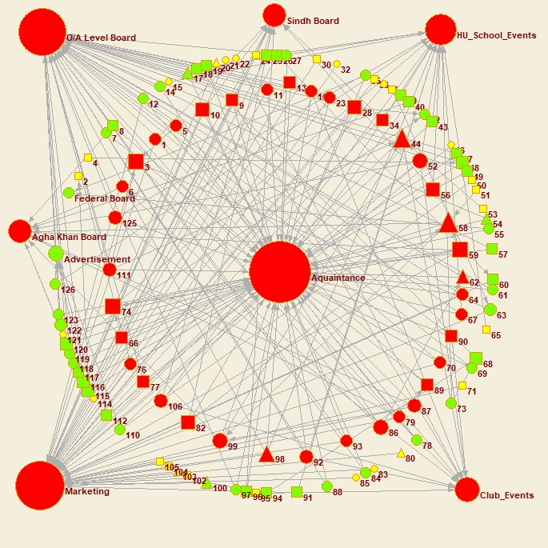

Fig 12 Graph of k-cores of the network